REVISION- ENGLISH 7

UNIT 7:TRAFFIC
A. GRAMMAR - NGỮ PHÁP
I. IT INDICATING DISTANCE – It dùng để chỉ khoảng cách
1. Cấu trúc
2. Cách dùng
Câu khẳng định | It + is + (about) + (a number) + unit of length+(from N_{place} to N_{place})  It + is + adj_{distance}
Câu phủ định | It + isn’t + adj_{distance}
Câu hỏi | How far is it from N_{place} to N_{place}?

Chúng ta có thể sử dụng it như một Chủ ngữ để chỉ khoảng cách từ một địa điểm này đến một địa điểm khác.
Ví dụ:
- It is about 10 kilometers from my house to my school. (Nhà tôi cách trường tôi khoảng 10 km.)
- How far is it from your home to your office? (Khoảng cách từ nhà bạn đến trường là bao xa?)
It is (about) 1500 meters.(Nó khoảng 1500 m.)
- How far is it from Ho Chi Minh City to Vung Tau? (Thành phố Hồ Chí Minh cách Vũng Tàu bao xa?)
It is not very far. (Không xa lắm)
3. Dấu hiệu nhận biết
Trong câu thường có một số đi kèm một đơn vị chỉ độ dài: a kilometer, 1000 meters, 500 miles, ...
Trong câu thường có tính từ chỉ khoảng cách: far, near,...
II. USED TO - Đã từng
1. Cấu trúc
Câu khẳng định | S + useto +V
Câu phủ định | S + didn't + use to + V
Câu hỏi | Did + S + use to + V?

2. Cách dùng chính
- Dùng để diễn tả một hành động đã từng được thực hiện trong quá khứ và đã chấm dứt.
Ví dụ:
- I used to play basketball, but now I like playing video games. (Tôi đã từng chơi bóng rổ, nhưng bây giò tôi thích chơi điện tử.)
- He used to be a soccer player. (Anh ấy từng là một cầu thủ bóng đá - Chủ thể của hành động trên ở thời điểm hiện tại không còn là một cầu thủ bóng đá nữa.)
- Diễn tả một sự việc chưa từng xảy ra trong quá khứ.
Ví dụ:
- They didn't use to be best friends. (Họ chưa từng là bạn than của nhau-Hànhđộng là bạn thân của nhau chưa từng xảy ra trong quá khứ, tuy nhiên chưa chắc đã không xảy ra trong hiện tại hoặc tương lai.)
- My father didn't use to buy a mobile phone for me, but in the future he will. (Bố của tôi chưa tùng mua cho tôi một chiếc di động nào cả, tuy nhiên trong tương lai có thể ông sẽ mua cho tôi.)
3. Dấu hiệu nhận biết
Trong câu thường có các động từ: used to, use to, didn't use to.
4. Lưu ý
- Trong câu hỏi hoặc trong câu phủ định, chữ "d" trong từ "used" sẽ bị bỏ đi.
Ví dụ:
- Did you used to play table tennis when you were a child? (Cậu đã từng chơi bóng bàn khi còn nhỏ chưa?)
- Did you used to walk to school? (Cậu đã từng đi bộ đến trường chưa?)
No, I didn't. I only went to school by car.(Không, tôi chỉ đến trường bằng ôtô.)
- I didn't used to play table tennis when I was a child. I used to play soccer and go swimming. (Tôi chưa từng chơi bóng bàn khi còn nhỏ. Tôi từng chơi bóng đá và đi bơi.)
- He didn't used to be a good student, but now he has a good job and can earn a lot of money. (Anh ấy chưa từng là một học sinh giỏi, nhưng bây giờ anh ấy tìm được một công việc tốt và có thể kiếm được rất nhiều tiền.)
B. EXERCISES
I. Find the word which has a different sound in the part underlined.
1. A.head B.break C.bread D.heavy
2. A.said B.wait C.maid D.sail
3. A.start B.lake C.station D.came
4. A.ancient B.radio C.nature D.village
5. A.indicate B.mistake C.take D.says
II. Put the means of transport into the correct groups.
bicycle (bike) boat bus car coach helicopter
lorry motorbike plane moped ship taxi
train tram (streetcar) underground van caravan kayak
Land | Air | Sea
…………………………………  …………………………………  …………………………………  ………………………………… | …………………………………  …………………………………  …………………………………  ………………………………… | …………………………………  …………………………………  …………………………………  …………………………………

III. Put the types of transport into the correct group of the verb. Some types of transport can be used more than once, and used with the article “a” or “the”.
bus plane train taxi car
helicopter bike horse motorbike ship
1. take:
2. get on:
3. get off:
4. go by:
5. ride:
IV. Look at signs A-F. What do they mean? Underline the correct option.
 A.Motorbikes don’t have to/ can’t go here. They have to/ don't have to go on another road.
B. You can/ have to park here for free. You can’t/ don’t have to pay for fifteen minutes parking.
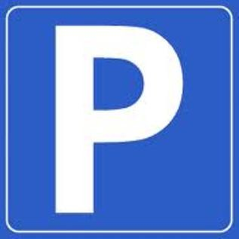 FREE

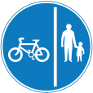 C. Bikes have to/ can keep left. People on foot don’t have to/ can’t walk on the left
D. You can/ can't catch the bus here. You have to/ don't have to wait more than ten minutes.
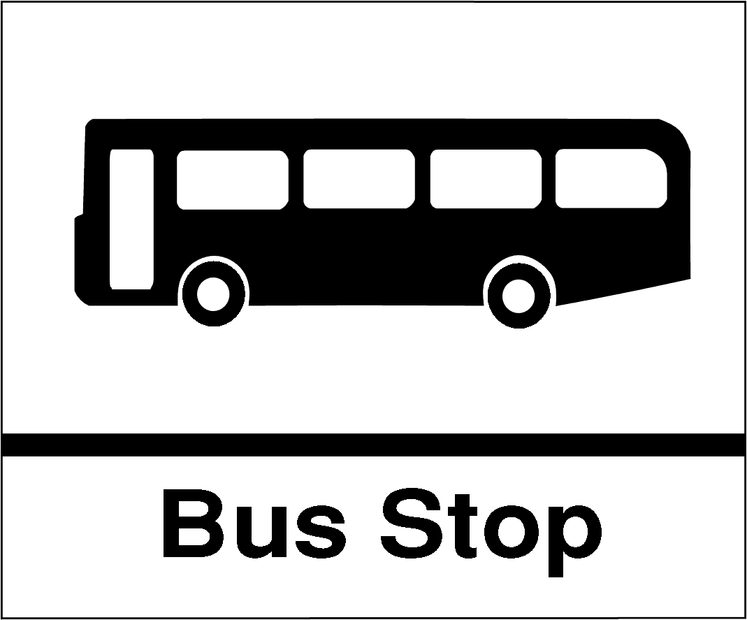 EVERY
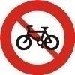 E. You can’t/ don’t have to ride your bike. You can/ have to get off and walk.
F. You can/ can't take a taxi here. You can/ can't park here.
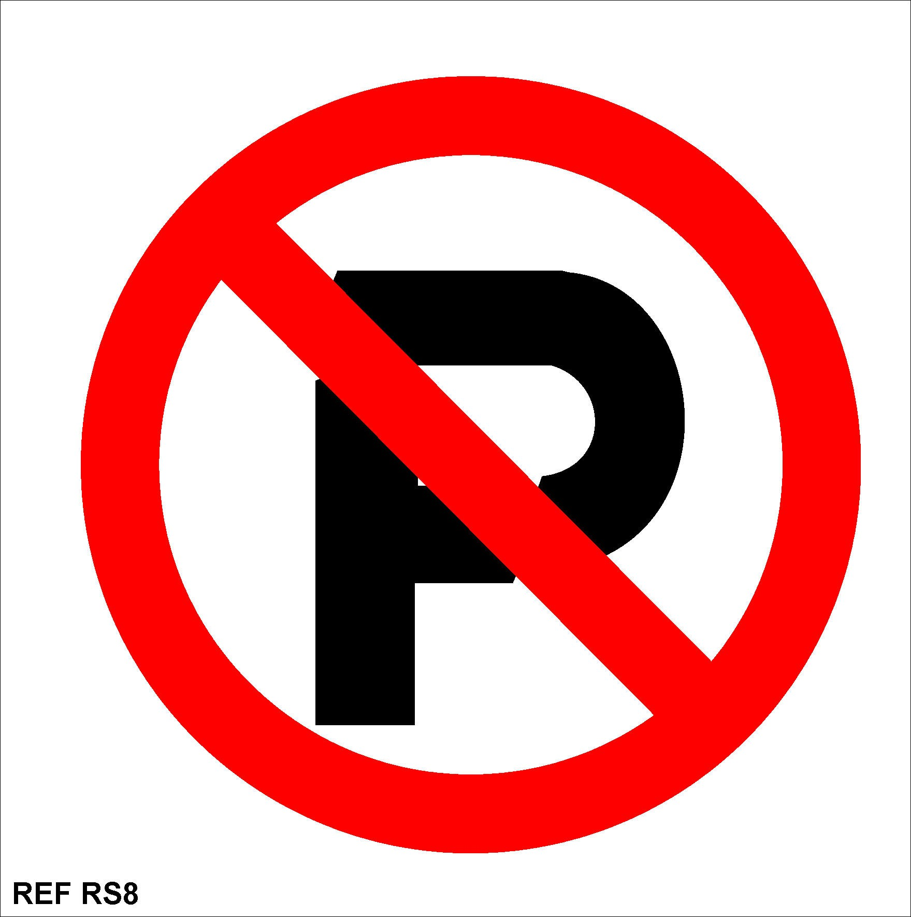TAXI
V. Complete the following sentences using a different verb or expression. Don’t change the meaning. Number 0 has been done for you as an example.
0. She never drives to the shops.
She never goes to the shops by car.
1. In bad weather, I take the bus to school.
In bad weather, I to school .
2. I always walk to my grandparents’ house.
I always to my grandparents’ house .
3. I usually go to school by bike.
I usually to school.
4. Do you go to school on foot?
Do you to school?
5. My father usually goes to work by car.
My father usually to work.
6. My mother drives me to the bus station.
My mother me to the bus station by .
VI. Complete the sentences with “used to” or “didn’t use to”.
1. I like sports, but now I do a lot of different sports.
2. I be afraid of heights, but then I started climbing hills.
3. I like putting my head in the water because I couldn’t swim.
4. I go skating until I met Anna in Switzerland, and then we have practised a lot so far.
5. I go to school on foot, but now I ride a bicycle to school.
VII. Read the following passage about driving laws around the world, and then tick the correct answers: true (T), or false (F).
In Sweden, it is necessary to keep your headlights on 24 hours a day. We understand that it is required for places as cold as Sweden during winter, but you cannot turn off your car’s lights even if it is June and the weather looks just fine.
If you are driving in Beijing and you come across a zebra crossing, don’t stop or even try to slow down because this will get you in trouble with the law.
In Thailand, it is compulsory to wear a shirt while driving. Women who go topless while driving can be fined equal to a few hundred baht.
In Cyprus, you should keep both hands on the wheel. Drivers who unnecessarily raise a hand from the steering wheel can get fines, although we think that making some gestures at bad drivers is sometimes good.
Don’t yell or curse while you are driving in Rockville, Maryland, USA although you are right. It is illegal to curse in public. You have to pay a fine up to $100 or go to prison up to 10 days.
Before you drive off with a car in Denmark, you must check that the children in your car have the best places. Maybe the reason is that they can read books by Hans Anderson.
Drinking and driving is illegal in Spain, but in Macedonia, if you are drunk, you cannot sit in the front seats.
True False
1. Use your car’s headlights 24 hours a day in Sweden.
2. In Sweden, you have to turn on your car’s lights in June when theweather is bad.
3. In Beijing, it is against the law to stop at a zebra crossing.
4. In Thailand, you have to wear a shirt while driving.
5. There are no rules about what women have to wear while they aredriving in Thailand.
6. In Cyprus, you cannot shake your fist (a hand with the fingers and thumb held tightly in)
at other drivers.
7. It is illegal to use bad language while you are driving in Rockville, Maryland, USA.
8. If you yell or curse while you are driving in Rockville, Maryland, USA and don't pay
the fine, you may be put in prison up to 90 days.
9. Children can have best places while they are riding in a car in Denmark.
10. Don’t sit in the front seats if you are drunk in Macedonia, Spain.
VIII. Read the texts about model good road safety behavior at all times for parents, and then answer the questions.
Top tips for pedestrian safety
- Teach your children to hold hands with an adult whenever they go out.
- Always use a zebra crossing when one is available and teach children that these are the safest places to cross.
- Teach children that it’s still important to stop, look and listen at a zebra crossing.
- Teach children always to stop at the kerb and look and listen for traffic (a third of children injured on roads said that they didn’t stop before stepping off the kerb and many said they didn’t look).
- Never use your mobile phone while crossing roads.
- Children learn to make decisions about crossing the road and parents gradually let them take a lead when you are crossing together.
- As children get older, practise routes with them before they walk alone.
Top tips for cycling
- Always encourage children to wear a cycle helmet when they are on their bikes, and set a good example by wearing one yourself.
- Children need to be able to judge speed and distance accurately before they cycle on public roads. They need to take lessons on cycling in order to travel more widely on their bikes.
- Make sure children wear bright coloured clothing and fluorescent items whenever they are cycling on the road. And if they are cycling in the dark, they will need lights on their bikes and reflective items too. And of course, make sure you do this yourself, to set a good example.
1. What should children do when they go out?

2. Where should children cross the street?

3. What should children do to cross the street?

4. Where should children stop to look and listen for the traffic?

5. Can they use their mobile phones while crossing roads?

6. What should parents do to help older children before they walk alone?

7. What should children wear when they are on the bikes?

8. What should children do before they cycle on public roads?

9. Which clothes should children wear whenever they are cycling on the road?

10. What should they do when they cycle in the dark?

IX.Make sentences using the words and phrases given.
1. The traffic/ a nightmare/ visitors/ Viet Nam/ the first time.

2. There/ transport rules/ but/ many people/ not seem/ really interested/ follow/ them.

3. Three or four people/ one motorbike/ a common sight/ particularly/ young people.

4. The traffic/ worst/ rush hours/ when/ everyone/ try/ get to work/ get home quickly.

5. Some people/ ride/ motorbikes/ the pavements/ rather than/ waiting/ a traffic jam.

6. Pedestrians/ get injured/ hit easily/ when/ they/ walk/ the pavements/ cross the roads/ such times.

7. Road users/ very impatient/ quite aggressive/ constantly using their horns/ even shouting/ others.

8. Some people/ install/ air horn/ their motorbikes/ this/ really annoying/ other people/ sometimes/ it/ cause/ accidents.

9. Another problem/ the increase/ the number/ cars/ the road.

10. More people/ own/ private cars/ it/ make/ the problem/ the traffic jams/ worse.

X. Complete the second sentence so that it has a similar meaning to the first.
1. I usually stayed up late to watch football matches last year, but now I don’t.
I used .
2. There were some frees in the field, but now there aren’t any.
There used .
3. Linda doesn’t live with her parents any more.
Linda used .
4. He is not a poor man any more, but he becomes a rich businessman.
He used .
5. They didn’t often go to the cinema every Sunday last year.
They didn’t use .
6. My hair now is much longer than that in the past.
In the past my hair used .
7. I don’t have time to collect stamps as when I was in primary school.
I used .

UNIT 8: FILMS
A. GRAMMAR - NGỮ PHÁP
I. ALTHOUGH, DESPITE/ IN SPITE OF- Mặc dù
1. Cấu trúc
Câu khẳng định | - Although + Clause, Clause.  - Despite/ In spite of + N/ N phrase, Clause.
Câu phủ định | - Although + Clause (phủ định), Clause  Although + Clause, Clause (phủ định)  - Despite/ In spite of + N, Clause (phủ định)  Despite/ In spite of + N phrase, Clause (phủ định)  Despite/ In spite of+not + N phrase, Clause.

2. Cách dùng
Chúng ta sử dụng although, despite/ in spite ofđể diễn tả sự đối lập của hai sự việc hiện tượng trong cùng một câu.
Ví dụ:
- Although he is so young, he performs excellently. (Mặc dù anh ấy rất trẻ, nhưng anh ấy thể hiện rất xuất sắc - Có thể thấy mệnh đề 1 có sự đối lập với mệnh đề 2, tuổi tác trẻ đồng nghĩa với việc thiếu kinh nghiệm và có sự đối lập với việc thể hiện xuất sắc, yêu cầu nhiều kinh nghiệm.)
- Despite/ In spite ofbeing so young, he performs excellently. (Mặc dù còn rất trẻ, nhưng anh ấy thể hiện rất xuất sắc - Có nghĩa tương tự như mệnh đề sửdụng Although, nhưng cấu trúc dạng despite/ in spite of chỉ đi với một cụm Danh từ đi ngay sau nó.)
- Despite/ In spite of his young age, he performs excellently. (Tương tự như trên, nhưng đi ngay sau despite/ in spite of là một Danh từ).
3. Dấu hiệu nhận biết
- Trong câu xuất hiện các trạng từ: although, though, even though, despite, in spite of...
- Trong câu chỉ xuất hiện phủ định ở một mệnh đề và không xuất hiện liên từ "but".
4. Lỗi thường hay gặp khi sử dụng cấu trúc although, despite/ in spite of
- Mặc dù có ý nghĩa giống nhau, nhưng cách sử dụng của although là khác so với despite/ in spite of. Chúng ta cần nhớ: ngay sau although (though/ even though)là một Clause, còn sau Despite/ In spite ofthì bắt buộc phải là một N hoặc N phrase.
- Trong câu sử dụng cấu trúc although, despite/ in spite ofkhông sử dụng liên từ but, cho dù dịch sang Tiếng Việt vẫn là Mặc dù..., nhưng...
II. HOWEVER, NEVERTHELESS - Tuy nhiên
1. Cấu trúc
- Clause 1. However/Nevertheless, Clause 2.
- Clause 1; however, Clause 2.
Ví dụ:
- I am good at English. However, I study Math so bad.
- She used to live in Ha Noi. Nevertheless, she is living in New York now.
2. Cách dùng chính
- Dùng để diễn tả hai câu có nội dung đối lập nhau.
Ví dụ:
- John used to be a bully. However, he is the most humorous and generous guy in my company now. (John từng là một kẻ chuyên đi bắt nạt người khác. Tuy nhiên, anh ta bây giờ là người vui tính và tốt bụng nhất trong công ty của tôi.)
- My family is poor. However, my parents always try to earn as much money as possible for my university education. (Gia đình của tôi là nghèo. Tuy nhiên, bố mẹ tối luôn cố gắng kiếm nhiều tiền nhất có thể để tôi có thể học đại học).
- My grandfather is a strict man. Nevertheless, he is the kindest person I have ever known.(Ông tôi là một ngưòi đàn ông nghiêm khắc. Tuy nhiên, ông là người tốt bụng nhất mà tôi từng biết đến.)
- I really love animals. Nevertheless, I only like raising loyal ones. (Tôi thực sự rất yêu quý động vật. Tuy nhiên tôi chỉ thích nuôi những con vật trung thành.)
3. Dấu hiệu nhận biết
- Trong câu xuất hiện các trạng từ sau: however, nevertheless ...
- Nghĩa của hai câu được đề cập là đối lập với nhau.
B. EXERCISES
I.Put the words in the correct column according to the pronunciation of the ending -ed.
washed looked stopped needed wanted decided
volunteered played watched raised appeared laughed
moved fascinated starred convinced shocked interested
/t/ | /d/ | /ɪd/
…………………………………  …………………………………  …………………………………  ………………………………… | …………………………………  …………………………………  …………………………………  ………………………………… | …………………………………  …………………………………  …………………………………  …………………………………

II. Complete the conversations with the correct form of the adjectives in brackets.
1. A: Was it a good film?
B: No, it wasn’t very (interest) . In fact, it was really (bore) .
2. A: I’m always very (tire) after a day at work. I can’t do anything in the evening.
B: Why don’t you watch a film?
A: I always fall asleep. Sometimes, I put on the most (excite) film that I really want to see but I always fall asleep
3. A: I’m an actor. Acting is a very (tire) job. It isn’t (relax) at all. Are you (relax) ?
B: No way. I’m a worker.
III. Complete the sentences with the correct form of the adjectives inthe box.
bore (x2) excite interest relax tire

1. I’m . I have nothing to do.
2. “Do you think yoga is ?” - “Oh, yes. It’s great. All my problems go after an hour of yoga.”
3. I’m .I didn’t sleep last night.
4. The film was . Nothing happened.
5. Ben was very about his birthday presents. He woke up at 5 a.m. and wanted to open them then.
6. This is a very book about the history of the cinema. I’m learning a lot.
IV. Complete the sentences, using although, despite, in spite of, however, or nevertheless. Sometimes, two answers are possible.
1. it was raining heavily, he went out without a raincoat.
2. My father is very busy. , he is always willing to give a hand with the housework.
3. Some English words have the same pronunciation they are spelled differently, for example, dear and deer.
4. I was cold and wet. , Bob put on his swimming suit and went to the beach.
5. I think I did OK in my speech last night I’d had almost no sleep for 24 hours.
6. Carol arrived at the meeting I asked her not to be there.
7. The sky was grey and cloudy. , we went to the beach.
8. It looks like they’re going to succeed their present difficulties.
9. there was no electricity, I was able to read because I had a candle.
10. I heard the telephone ring, I didn’t answer it.
V. Read the conversation, and then answer the questions.
Susan: Sorry, guys, the Batman film’s sold out. Which film will we see instead?
Linda: How about this? It’s called Girl of my Dreams. It’s about a young man who dreamtabout a perfect girl. The next day he went to the bookshop where he met a girl called Nina.
Nick: That’s a love story. No, thank you!
Paul: What about Journey into Space? It’s about some spacemen who go to Mars.
Linda: Mm. It doesn’t sound very exciting. Is there anything else on?
Susan: How about The Pyramid? It’s a horror film about a monster in an Egyptianpyramid which comes alive.
Paul: OK, that’s better. Shall I get the tickets?
Susan: Yes, but let’s hurry. It’s half past five. The next performance starts in five minutes.
1. Which film do they want to see at first?

2. Why can’t they see it?

3. Which films do Linda, Paul, and Susan suggest that they see?

4. What types of film are they?

5. Which film do they agree to see?

VI. Read the film review, and then answer the questions.

A Kid in King Arthur’s Court is directed by Michael Gottlieb. The main character in the film is a teenager called Calvin Fuller. Calvin is played by Thomas Ian Nicholas. This film is a modem retelling of Mark Twain’s classic book Connecticut Yankee.
Calvin lives in California, USA. He is a very shy boy and he is not very goodat sports. At the beginning of the film, Calvin is playing baseball when there is a terrible earthquake. A hole opens in the ground and Calvin falls through it. He lands in the past, in the time of King Arthur.
Calvin meets King Arthur and Merlin, the wizard. King Arthur is played by Joss Ackland and Merlin is played by Ron Moody. They think that Calvin is amazing because he plays them modem music on his CD player and he shows them how to make rollerblades and a mountain bike. Calvin is trained to be a knight and he becomes more confident. Calvin helps King Arthur to beat his enemy, Lord Belasco, and then Merlin sends Calvin back to the future. Calvin finds himself back in the baseball game, but this time he wins the game.
The special effects in A Kid in King Arthur's Court are very good. Michael Gottlieb is a great director and the actors’ performances are good. The film is funny and exciting. It’s a comedy, a drama, and an action film all in one.
1. What type is the film “A Kid in King Arthur ’s Court”?

2. Who is the main character? By whom is it played?

3. Who is the director of the film? Is he a good director?

4. What is Calvin doing when the earthquake happens?

5. How can he land in the time of King Arthur?

6. Why do King Arthur and Merlin think that Calvin is amazing?

7. Who is Calvin trained to become?

8. What does Calvin do to help King Arthur?

9. How can Calvin come back to the present time?

10. How are the special effects in the film?

11. How are the actors’ performances?

12. What does the writer think about the film?

VII. Rewrite the sentences, using the words in the brackets. Change other words in the sentence if necessary.
1. I couldn’t sleep. I was tired. (in spite of)

2. They have little money. They are happy. (despite)

3. My foot was hurt. I managed to walk to the nearest village. (although)

4. We planned to visit Petronasin the afternoon. We could not afford the fee. (however)

5. I got very wet in the rain. I had an umbrella. (although)

6. The new restaurant looks good. It seems to have few customers. (however)

7. We had planned to walk right round the lake. The heavy rain made this impossible. (although)

8. I’ve been too busy to answer my email. I’ll do it soon. (nevertheless)

9. Mary was sick. She didn’t leave the meeting until it ended.(despite)

10. We live in the same sweet. We rarely see each other. (in spite of)
___________________________________________________________________________________

